Curry Supply Expands Market Opportunity with New Facility in Houston, Texas
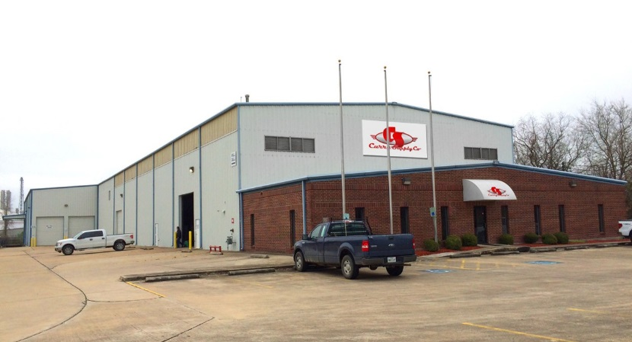
MARTINSBURG, PA – Curry Supply Company, a leading manufacturer and dealer of commercial service vehicles, has announced the opening of a new facility in Houston, Texas to better serve customers in the southwestern United States.
The 32,000 square foot facility has sales representatives available to provide quotes, technical support, and financing. An extensive parts inventory of the most commonly requested parts and components will be housed there for immediate shipping. Heavy duty overhead cranes are installed throughout the facility to easily move product during the manufacturing and assembly process. In addition, a state-of-the-art paint and curing booth allows for on-site painting to ensure that quality is maintained to Curry Supply standards.
A full inventory of products will be prepped and ready to ship from the new Houston facility, including On- and Off-Road Water Trucks, Mechanics Trucks, Service Trucks, On- and Off-Road Fuel/Lube Trucks, Vacuum Trucks, Winch Trucks, Dump Trucks, Crash Attenuator Trucks, Ship Out Tank Kits, and Lube Trailers.
“Having a facility in Houston permits us to better serve the construction, equipment rental, oil and gas, and mining industries in the southwest,” said Jason Ritchey, president. “We have always been able to ship our products worldwide, but having sales, parts, and inventory in one of our largest growing markets is a convenience for our customers located in that region.”
Martinsburg, Pennsylvania continues to be the Curry Supply’s worldwide headquarters. Their new facility is located at 1113 Howard Avenue, Deer Park (Houston), Texas. For more information, contact them by phone at 800-345-2829, by email sales@currysupply.com, or visit their website: www.currysupply.com.
Curry Supply Company is a family-owned business that was established in 1932. Over the past 80 years, Curry Supply has grown into one of America’s largest manufacturers and dealers of commercial service vehicles. Sales and service is provided throughout the United States with financing and international delivery available.
# # #

